Insert school name and crest

Commerce

Employment & Work Futures
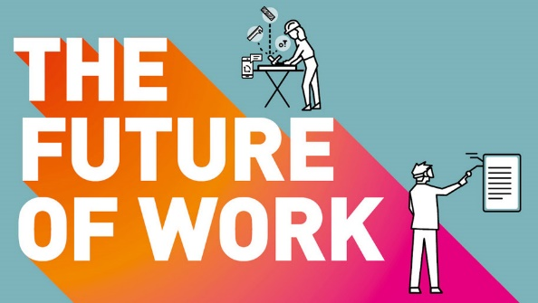

Work Booklet
Student: _________________________
Teacher: _________________________

Keith Thomas, Cumberland HS

From the syllabus: Employment & Work Futures
Content focus
Students investigate the contribution of work to the individual and society and the changing nature of work. They examine how individuals may derive an income, and the changing rights and responsibilities of workplace participants. Students analyse a range of perspectives in their consideration of employment and work futures.

Skills to be integrated in this topic as appropriate:
Developing questions, gathering and processing relevant information, analysing familiar and new situations, evaluating options, developing and implementing plans, developing evidence-based conclusions/decisions and reasoned arguments, working independently and collaboratively.
Content
Work and wellbeing
Students:
Examine the contribution of work to the wellbeing of individuals and broader society, including:
– the relationship of work to quality of life, eg disposable income, health, household economic wellbeing, superannuation accrual, household management
– contributing to an individual’s self-esteem and material and non-material living standards
– the redistribution of income through taxation, and government expenditure, eg in education, health, infrastructure and social welfare

The workplace
Students:
Compare the types of work and work arrangements, including full-time, part-time, casual, at home, paid, unpaid, voluntary, apprenticeships, traineeships
Examine various sources of income, including wages and salaries, commissions, profits and dividends investigate how the nature of work has changed and how it is likely to change in the future, including:
– the use of statistical data to examine patterns of employment
– the emergence of the sharing economy
– changes in the nature of work and workplace arrangements due to the impact of technology and globalisation
From the syllabus: Employment & Work Futures continued….

Rights and responsibilities in the workplace
Students:
investigate the roles of various participants in the workplace, including employers, employees, contractors, industrial organisations/unions, state/territory and Commonwealth governments
explain changes to the roles of employees in the workplace, for example the increasing encouragement for workers to show initiative
discuss employer responsibilities to workers and the government, for example superannuation, paid parental leave, pay as you go (PAYG) withholding, income tax, company tax or the Goods and Services Tax (GST)
examine laws related to the workplace, including:
– Work Health and Safety (WHS) legislation
– Equal Employment Opportunity and anti-discrimination laws
– penalty rates and the role of the Fair Work Commission • identify methods of resolving disputes, including grievance procedures, negotiation, mediation, arbitration

Current issues
Students:
investigate a current issue related to the workplace that has affected employees in Australia, for example:
– workplace discrimination on the basis of, eg age, disability, ethnicity, gender, culture
– the ways in which different groups in society have been affected by one current employment relations issue – artificial intelligence and/or robotic technology and its impact on the workforce
– the nature of unemployment and implications for the individual, groups and society

INTRODUCTORY ACTIVITIES

Research task – research into 3 careers /jobs and report back to class on the “entry requirements” (tertiary education, white card, level of experience etc)
Role play scenarios (in groups of varying sizes):
- a job interview
- an employee being dismissed (sacked / fired!)
- a workmate being discriminated against based on race / colour
- a workmate being discriminated against based on religion
- a boss harassing a worker
- a strike (industrial action) for higher pay
- a worker not having a good work ethic and being dealt with by the boss
Debate topics – provide reasons for and against. Place an * next to the ones you believe in / agree with. Report + and – to the class, turn about, until ideas are exhausted.
+ | -

- People on “the dole” (unemployment benefits) should have to volunteer or be in the Army Reserve.
- If someone doesn’t go to university they are a ‘loser’!
- Tradespeople are extremely valuable to our society.
- On the job training can be important or more important than what is learnt in formal education.
- A lot of university educated people are ‘tossers’.

7.30 Report series:
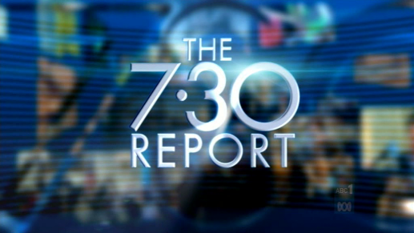
https://www.abc.net.au/7.30/what-will-education-in-australia-look-like-in-2025/12547738
EPISODE 1: Transcript

What will education in Australia look like in 2025?
WOMAN: Gosh, okay, so in Australia in 2025...
WOMAN 2: Australia would be, um...
WOMAN 3: I see us banding together after the challenging times that we're going through now.
ANDY PARK, REPORTER: 2025 is less than five years away but right now with recessions and climate change and the pandemic, in my lifetime, even in my parents' lifetime, there's never been more uncertainty about what the near future will hold.
MAN: Jobs of the 21st Century should be our primary thought.
JAN OWEN, LEARNING CREATES AUSTRALIA: The promise that we've made, which is that you do get a house, and you do get security and you can have a family if you want, that promise is broken at the moment for a generation of young people.
MAN 2: The future of work doesn't look very exciting at all. It's not shiny, it's not driven by technology. It's driven by a fight for survival.
ANDY PARK: In this series, we join with Australians living through uncertain times, making plans, changing course, adapting the best way they can and on the way, we might learn something about the Australia of 2025.
AMBROSIA JACKSON: Hi, my name is Ambrosia Jackson. I'm 17-years-old and I go to Beenleigh State High School. Um... I don't really know what else to say. Sorry, this is really awkward.
My dream is to own my own coffee shop. What worries me about the future is TAFE and stuff, and just worried that I won't complete it.
ANDY PARK: Ambrosia's school day begins at 7:00am in Logan City in South East Queensland, an area with high youth unemployment.
AMBROSIA JACKSON: Morning. How are you?
CUSTOMER: Good thanks.
ANDY PARK: Professor Peter Shergold is Chancellor of Western Sydney University.
PROF. PETER SHERGOLD, CHANCELLOR, WESTERN SYDNEY UNIVERSITY: If you go back to the group who graduated from school during the global financial crisis, that in fact they had been disadvantaged. They are still playing catch-up.
MATT O'HANLON, PRINCIPAL, BEENLEIGH STATE HIGH: So Ambrosia, can you make me a long black?
AMBROSIA JACKSON: Yes, of course, I can.
MATT O'HANLON: The most important thing is that these are real skills, industry skills, that kids can take out into the workforce.
ANDY PARK: Beenleigh State High School is one of a handful of schools around the country piloting an alternative academic measurement to the Australian Tertiary Admission Rank, or ATAR.
The hope is by 2025, graduates like her will have a more rounded portrait of their skills to take to employers.
MATT O'HANLON: Let's look at the barista one because that's more important to you. Now the other thing is, it will also throw you and show you where jobs are available.
AMBROSIA JACKSON: Oh, that's so cool.
MATT O'HANLON: She's developed skills in communication. It's very difficult to teach that in a classroom setting.
PETER SHERGOLD: We tend to think that all the jobs for the future are going to be high technology and research-based jobs. You can almost see a split into the future of coders and carers.
And somehow, we have to say in our education system, whoa, wait on there. Actually, what you're learning here, whether you're doing history or plumbing, in a sense, are attributes that you need which is communication, complex problem solving, ability to work as part of a team.
ANDY PARK: Professor Peter Shergold's report on senior secondary students found that ATAR cannot continue to dominate the education experience.
PETER SHERGOLD: I think ATAR is, in a real sense, distorting our seniors secondary education system. I do foresee, to be honest, its slow death over the next five years.
What you need to do, going through school and beyond, is learn to learn because the only thing that I'm certain about in an uncertain future is that you will not be going in to trades or professional careers that are going to be the same for 40 years.
ANDY PARK: New research from the Centre of Future Work shows relatively few jobs have been created in the most technology and innovation intensive industries.
More jobs have been created in relatively low-tech sectors like the one Ambrosia is headed for, where innovation has been very slow.
ALEX ZAMMIT: My name is Alex Zammit. I'm 18-years-old. I got to Westbourne Grammar in Year 12 and by 2025 I will be graduated at Melbourne University with a Bachelor of Biomedicine.
ANDY PARK: Alex's ATAR is his key to a future in the booming biomed industry.
ALEX ZAMMIT: It's quite stressful knowing I need to do quite well. My mum's job was vastly impacted during coronavirus. She lost about 60 per cent of her work overnight.
ANDY PARK: By 2025, when Alex completes his degree, he will be in a more competitive environment for high end jobs than ever, if trends continue.
The Productivity Commission recently found that young people aged 25 to 34 with bachelor degrees are substantially worse off in 2018 than they were in 2001.
Jan Owen is from Learning Creates Australia, a group of organisations wanting to transform education.
JAN OWEN: There's a scarring effect of events like COVID-19 on young people's lives which will continue for potentially decades.
ANDY PARK: By 2025, traditional degrees like Alex's with slow employment payoffs will be increasingly out of favour over something called micro-credentialing.
JAN OWEN: We expect a 15-year-old today to have 17 jobs in five different industries across their life - that is not going to be 17 degrees.
PETER SHERGOLD: A revolution is going on in terms of the education that people can gain, particularly online.
Whatever the future holds, it's going to require higher levels of digital literacy and that has got to be a focus if we are going to be serious about education being the platform for equal opportunity in Australia.
ANDY PARK: Not everyone takes the university path and those who don't are often in work sooner.
MATT CARROLL: By 2025, I will be a qualified electrician or even possibly starting my own business if I do have the potential to.
ANDY PARK: Matt Carroll is hoping an apprenticeship will make him one of the estimated 44,000 Australians with jobs in the renewable energy industry by 2025.
MATT CARROLL: Going through this pandemic solidifies that all tradesmen are always going to have work. Even now lots of people are investing in solar systems, especially with additional home batteries as well.
ANDY PARK: To address a 36 per cent drop in new apprenticeships this year, the Government announced a $1 billion JobTrainer scheme but according to analysis provided to 7.30 by the Mitchell Institute, this money will only be enough to fund short courses, not full qualifications. For their part, the Government says it will be a mix.
The Shergold report says pathways like these have unfairly been perceived as second-class.
PETER SHERGOLD: What are we doing about the 70 per cent of students at school who are not using ATAR to get to university?
We often talk to young people at school as if there's this binary choice between higher education and vocational education and training. In fact, what we know from life is that increasingly people will shift between those two throughout their life.
MATT CARROLL: If someone wanted to go for a trade instead of taking the normal route that we have in society through uni and all that kind of stuff, I'd definitely them towards it.
JAN OWEN: We're facing a cliff, that even this year, it's very, very serious because if those young people can't find a path of some kind, so into further learning, into jobs, into apprenticeships, into internships, we need to kind of open up all the opportunities as far as we can.
ANDY PARK: Three students attempting to create certainty out uncertainty.
JAN OWEN: We genuinely have an opportunity to think about the learning path.
ANDY PARK: The choices they make now, just as we make as a nation, will be crucial for the future of Australia in 2025.
PETER SHERGOLD: Somehow you have got to be prepared to be agile, to be creative and to able to keep on doing it.

https://www.abc.net.au/7.30/the-future-of-jobs-in-manufacturing,-energy-and/12556590
EPISODE 2: Transcript
The future of jobs in manufacturing, energy and technology
ANDY PARK, REPORTER: As Australians adapt to the greatest changes since World War II, so too are our industries.
ANDREW LIVERIS, COVID-19 MANUFACTURERS TASKFORCE: We have got to actually have some capability onshore to mitigate against the risk that we won't be able to get it from offshore.
ANDY PARK: So where are the future jobs for the workers of Australia in 2025?
DR LARRY MARSHALL, CEO, CSIRO: Innovation in Australia went down consistently over 30 years of uninterrupted economic growth.
So it seems like we need a crisis to get us off our backsides and get us working together.
DES WATKINS, WATKINS STEEL: Things have changed so much. I currently have got three daughters and when I was their age, my father taught me how to cut steel and weld steel but the way that things are changing in the industry, I'm teaching them how to program robotics and how to laser scan.
ANDY PARK: The clarion call to revamp Australia's manufacturing sector and provide jobs in life after corona has been heard here, just north of Brisbane.
DES WATKINS: I remember the first line of robotics we got; not too sure it was the right move but what I realised was every line of robotics we commissioned we actually employed a further 10 people.
ANDY PARK: Des Watkins says that it's business that needs to invest in both staff and technology.
DES WATKINS: You often hear things about the skill set or there's not enough training going on. But even Watkins here, we identified we are going to need more staff, we are going to need more skills, we are going to need more boiler makers.
So not so much what the government is doing about it, but what we're doing about it.
CLEM GILES: My dad worked in printing and his role changed when they got rid of the typesetting.
ANDY PARK: Clem Giles began here as an unskilled labourer eight years ago. Today he does a job that didn't exist back then.
CLEM GILES: I was asked if I would be able to operate the first machine that Watkins Steel bought, which was a robot coping machine, and I sort of leapt at the opportunity.
ANDY PARK: For all the investment in manufacturing, jobs in the sector are on the decline.
Analysis from global professional services firm, EY, reveals manufacturing employment in Australia has decreased by 6.7 per cent over the past five years and, despite an enormous amount of money spent on R&D in manufacturing, the industry only contributes 5.6 per cent to GDP which is way below other OECD countries.
Andrew Liveris has advised the Obama and Trump administrations and now the Australian Government about revitalising the sector.
ANDREW LIVERIS: When we think manufacturing in this country, we think of the factory, we think of production with smokestacks.
In fact, manufacturing of the 21st century is, in fact, the ecosystem of R&D design.
We're good at digging things out of the ground, min tech, how about value-adding to the minerals? How about taking our rare earths, how about taking our lithiums? How about going all the way and making batteries here in this country?
How about going all the way and making solar panels in this country? How about making wind turbines in this country?
So we should have a policy that works with the private sector to help focus in on the sectors we can be good at - five, six, or seven that have been identified that I'm aware of - that we can actually scale and create those jobs for the next generation.
That should be one of our primary responsibilities. COVID has just brought it home.
ANDY PARK: And yet Australia's robotics take-up remains slow. There are just 83 industrial robots in service for every 10,000 manufacturing workers and investment in machinery and equipment is the weakest level since World War II.
Jo Masters is chief economist at consulting firm, EY.
JO MASTERS, CHIEF ECONOMIST, EY: I don't think the manufacturing in Australia in the future, in 2025, will look anything like it did in the past. In the past we have got clear examples of manufacturing of areas that were protected by tariffs, for example.
Australia's a small, open economy, we have a small domestic market. We need to be outward looking if we're going to have a robust, resilient, flourishing manufacturing sector.
ANDY PARK: Larry Marshall leads the national science agency.
LARRY MARSHALL: To do truly agile manufacturing where you can rapidly shift from one product to another, you need robotics, you need machine learning, but knowing what product to make and how to make it unique, you can't do that without humans.
KRISTEN MCPHAIL, PACHAMAMA CHILDCARE CENTRE: What worries me about the future is children not getting out and playing enough, is them staying inside and concentrating on their technology.
(To children) One, two, three! Let's have a look!
ANDY PARK: Director of a Perth's Pachamama Childcare Center, Kristen McPhail moved into childcare from financial services after eying off an opportunity.
KRISTEN MCPHAIL: Childcare is a growth industry. Families are going to need more and more childcare in the future.
ANDY PARK: As a sector, childcare, healthcare and education have seen the lowest R&D and innovation investment and yet have seen the biggest increase in jobs - 593,000 from 2014 to 2019.
KRISTEN MCPHAIL: In regards to early education, you can't automate taking care of children. You can't automate their learning. You can't automate building relationships that the children so desperately need.
JIM STANFORD, CENTRE FOR FUTURE WORK: The good news is we're going to need hundreds of thousands more Australians performing child care, aged care, healthcare, education.
The bad news is because of the way we've underfunded those services, the quality and compensation of those jobs is too low, far lower than it should be.
LARRY MARSHALL: We call it the Australian national outlook. Try to use science to predict what markets and what industries would be most successful for Australia over the next few decades.
ANDY PARK: The CSIRO road map forward points to potential industries with a huge future for Australia in 2025 and beyond.
LARRY MARSHALL: We know, regardless of what we may think, opinions about climate change, we know that the world is going to zero emissions. That's a market trend.
So forget the politics, forget the ideology. It's a market trend and we can either be damaged by that or we can recognise that and actually try and take advantage of that.
ANDY PARK: Regions like Tasmania's Tamar Valley have long been bystanders to crumbling industry and dying jobs.
The latest being tourism, thanks to COVID, which had accounted for 17 per cent of all jobs in the state.
MICHAEL BAILEY, TAS. CHAMBER OF COMMERCE AND INDUSTRY: When I walk the streets in Tasmania and see unemployed people, whether they be young or old, what I see is a real lost opportunity in our state.
ANDY PARK: Michael Bailey is a proponent of a new plan to transform his state into the battery of the nation.
MICHAEL BAILEY: One of the great ideas that's been floating around for the last few years that is now really getting momentum, is how we can build a plant in Tasmania, maybe more than one plant, to produce hydrogen.
ANDY PARK: Hydroelectric power in Tasmania is already world-class but new clean, green hydrogen technology could leave behind much more than just the by-product of water.
Tasmania expects to be fully powered by renewable energy by 2022, exporting the excess energy using existing infrastructure and opening up a market worth $10 billion by 2040.
MICHAEL BAILEY: Without this sort of innovation in Tasmania, we will be left behind by 2025.
LARRY MARSHALL: So Tasmania, Gladstone in Queensland, parts of Western Australia, places where we dig up raw materials from the ground, and put them on ships and send them overseas, I think the future is going to be different to that.
Rather than just shipping raw material, we are going to add value to that raw material.
ANDREW LIVERIS: For the energy intensive industries, there is about 200,000 jobs at risk in this country if we don't actually create that and going overnight to renewables is incredibly difficult to do it because renewables don't give you base power - yet. They will.
I'm a big fan of putting in sovereign capability to protect ourselves, but also to create next generation jobs.
ANDY PARK: To build the Australia of 2025, the jobs and industries of the future will not rely on the past.
JO MASTERS: We are a long way from many parts of the world so we need to invest in technology and human capital that can try and offset some of that high cost base and make the most of Australian products in the global market.

https://www.abc.net.au/7.30/the-future-of-jobs-in-manufacturing,-energy-and/12556590
EPISODE 3: Transcript

The future of jobs in manufacturing, energy and technology
ANDY PARK, REPORTER: As Australians adapt to the greatest changes since World War II, so too are our industries.
ANDREW LIVERIS, COVID-19 MANUFACTURERS TASKFORCE: We have got to actually have some capability onshore to mitigate against the risk that we won't be able to get it from offshore.
ANDY PARK: So where are the future jobs for the workers of Australia in 2025?
DR LARRY MARSHALL, CEO, CSIRO: Innovation in Australia went down consistently over 30 years of uninterrupted economic growth.
So it seems like we need a crisis to get us off our backsides and get us working together.
DES WATKINS, WATKINS STEEL: Things have changed so much. I currently have got three daughters and when I was their age, my father taught me how to cut steel and weld steel but the way that things are changing in the industry, I'm teaching them how to program robotics and how to laser scan.
ANDY PARK: The clarion call to revamp Australia's manufacturing sector and provide jobs in life after corona has been heard here, just north of Brisbane.
DES WATKINS: I remember the first line of robotics we got; not too sure it was the right move but what I realised was every line of robotics we commissioned we actually employed a further 10 people.
ANDY PARK: Des Watkins says that it's business that needs to invest in both staff and technology.
DES WATKINS: You often hear things about the skill set or there's not enough training going on. But even Watkins here, we identified we are going to need more staff, we are going to need more skills, we are going to need more boiler makers.
So not so much what the government is doing about it, but what we're doing about it.
CLEM GILES: My dad worked in printing and his role changed when they got rid of the typesetting.
ANDY PARK: Clem Giles began here as an unskilled labourer eight years ago. Today he does a job that didn't exist back then.
CLEM GILES: I was asked if I would be able to operate the first machine that Watkins Steel bought, which was a robot coping machine, and I sort of leapt at the opportunity.
ANDY PARK: For all the investment in manufacturing, jobs in the sector are on the decline.
Analysis from global professional services firm, EY, reveals manufacturing employment in Australia has decreased by 6.7 per cent over the past five years and, despite an enormous amount of money spent on R&D in manufacturing, the industry only contributes 5.6 per cent to GDP which is way below other OECD countries.
Andrew Liveris has advised the Obama and Trump administrations and now the Australian Government about revitalising the sector.
ANDREW LIVERIS: When we think manufacturing in this country, we think of the factory, we think of production with smokestacks.
In fact, manufacturing of the 21st century is, in fact, the ecosystem of R&D design.
We're good at digging things out of the ground, min tech, how about value-adding to the minerals? How about taking our rare earths, how about taking our lithiums? How about going all the way and making batteries here in this country?
How about going all the way and making solar panels in this country? How about making wind turbines in this country?
So we should have a policy that works with the private sector to help focus in on the sectors we can be good at - five, six, or seven that have been identified that I'm aware of - that we can actually scale and create those jobs for the next generation.
That should be one of our primary responsibilities. COVID has just brought it home.
ANDY PARK: And yet Australia's robotics take-up remains slow. There are just 83 industrial robots in service for every 10,000 manufacturing workers and investment in machinery and equipment is the weakest level since World War II.
Jo Masters is chief economist at consulting firm, EY.
JO MASTERS, CHIEF ECONOMIST, EY: I don't think the manufacturing in Australia in the future, in 2025, will look anything like it did in the past. In the past we have got clear examples of manufacturing of areas that were protected by tariffs, for example.
Australia's a small, open economy, we have a small domestic market. We need to be outward looking if we're going to have a robust, resilient, flourishing manufacturing sector.
ANDY PARK: Larry Marshall leads the national science agency.
LARRY MARSHALL: To do truly agile manufacturing where you can rapidly shift from one product to another, you need robotics, you need machine learning, but knowing what product to make and how to make it unique, you can't do that without humans.
KRISTEN MCPHAIL, PACHAMAMA CHILDCARE CENTRE: What worries me about the future is children not getting out and playing enough, is them staying inside and concentrating on their technology.
(To children) One, two, three! Let's have a look!
ANDY PARK: Director of a Perth's Pachamama Childcare Center, Kristen McPhail moved into childcare from financial services after eying off an opportunity.
KRISTEN MCPHAIL: Childcare is a growth industry. Families are going to need more and more childcare in the future.
ANDY PARK: As a sector, childcare, healthcare and education have seen the lowest R&D and innovation investment and yet have seen the biggest increase in jobs - 593,000 from 2014 to 2019.
KRISTEN MCPHAIL: In regards to early education, you can't automate taking care of children. You can't automate their learning. You can't automate building relationships that the children so desperately need.
JIM STANFORD, CENTRE FOR FUTURE WORK: The good news is we're going to need hundreds of thousands more Australians performing child care, aged care, healthcare, education.
The bad news is because of the way we've underfunded those services, the quality and compensation of those jobs is too low, far lower than it should be.
LARRY MARSHALL: We call it the Australian national outlook. Try to use science to predict what markets and what industries would be most successful for Australia over the next few decades.
ANDY PARK: The CSIRO road map forward points to potential industries with a huge future for Australia in 2025 and beyond.
LARRY MARSHALL: We know, regardless of what we may think, opinions about climate change, we know that the world is going to zero emissions. That's a market trend.
So forget the politics, forget the ideology. It's a market trend and we can either be damaged by that or we can recognise that and actually try and take advantage of that.
ANDY PARK: Regions like Tasmania's Tamar Valley have long been bystanders to crumbling industry and dying jobs.
The latest being tourism, thanks to COVID, which had accounted for 17 per cent of all jobs in the state.
MICHAEL BAILEY, TAS. CHAMBER OF COMMERCE AND INDUSTRY: When I walk the streets in Tasmania and see unemployed people, whether they be young or old, what I see is a real lost opportunity in our state.
ANDY PARK: Michael Bailey is a proponent of a new plan to transform his state into the battery of the nation.
MICHAEL BAILEY: One of the great ideas that's been floating around for the last few years that is now really getting momentum, is how we can build a plant in Tasmania, maybe more than one plant, to produce hydrogen.
ANDY PARK: Hydroelectric power in Tasmania is already world-class but new clean, green hydrogen technology could leave behind much more than just the by-product of water.
Tasmania expects to be fully powered by renewable energy by 2022, exporting the excess energy using existing infrastructure and opening up a market worth $10 billion by 2040.
MICHAEL BAILEY: Without this sort of innovation in Tasmania, we will be left behind by 2025.
LARRY MARSHALL: So Tasmania, Gladstone in Queensland, parts of Western Australia, places where we dig up raw materials from the ground, and put them on ships and send them overseas, I think the future is going to be different to that.
Rather than just shipping raw material, we are going to add value to that raw material.
ANDREW LIVERIS: For the energy intensive industries, there is about 200,000 jobs at risk in this country if we don't actually create that and going overnight to renewables is incredibly difficult to do it because renewables don't give you base power - yet. They will.
I'm a big fan of putting in sovereign capability to protect ourselves, but also to create next generation jobs.
ANDY PARK: To build the Australia of 2025, the jobs and industries of the future will not rely on the past.
JO MASTERS: We are a long way from many parts of the world so we need to invest in technology and human capital that can try and offset some of that high cost base and make the most of Australian products in the global market.
ANDY PARK: The jobs of tomorrow created by decisions made today.

JOB ADVERTISMENT TASK

Task: You have been hired by an advertising firm to create a job advertisement for your dream job. Please go to various jobs seeking websites such as Seek, Careerone etc to get some ideas for your job advertisement. Your advertisement can be in any of the following formats:
- Poster
- Newspaper article
- Online advertisement
- Pamphlet
- Handout
- Any other ideas you feel may be appropriate (please consult your teacher before proceeding with another format not listed above)
You may be as creative as you like. Your dream job could be anything from a garbage collector, to a teacher or nurse to a chemical engineer or pilot.
You must have the following points in your advertisement.
- The name of the job
- Skills required
- The salary/wage of the job
- The type of employment
- Education requirements
- All other relevant aspects related to the job


Work and wellbeing
Students:
Examine the contribution of work to the wellbeing of individuals and broader society, including:
– the relationship of work to quality of life, eg disposable income, health, household economic wellbeing, superannuation accrual, household management
– contributing to an individual’s self-esteem and material and non-material living standards
– the redistribution of income through taxation, and government expenditure, eg in education, health, infrastructure and social welfare
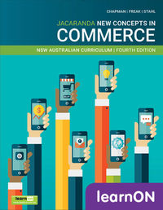
TEXT BOOK WORK!!!
Study the photographs in section 3.1.1 and fill in the blanks below.
(a) Using your knowledge of workplaces, suggest three different occupations that these people might be engaged in.
________________________________________________________________________
________________________________________________________________________
________________________________________________________________________
________________________________________________________________________
________________________________________________________________________

- Look closely at the people shown. What sort of place do you think this might be to work in? Consider dress, work space and level of formality.
________________________________________________________________________
________________________________________________________________________
________________________________________________________________________

- List two office work environments that this clearly is not an example of, then provide one reason for each based on what you see in the picture and what you know of the world of work.
________________________________________________________________________
________________________________________________________________________
________________________________________________________________________

THE BENEFITS of WORK
TEXT BOOK WORK!!!
Read pages 112-117 and complete the table with brief notes.
BENEFIT | DESCRIPTION

Work and wellbeing

Complete either (a) or (b)
- Think of someone you know who works full time. This might be someone in your family, a teacher, friend or someone you know in your neighbourhood. Describe what do you think their perfect ‘work–life balance’ day would be like.
OR
- Write a diary entry of the perfect work–life balance day, set in the future when you are working in that job.

_______________________________________________________________________________________________________________________________________________________________________________________________________________________________________________________________________________________________________________________________________________________________________________________________________________________________________________________________________________________________________________________________________________________________________________________________________________________________________________________________________________________________________________________________________________________________________________________________________________________________________________________________________________________________________________________________________________________________________________________________________________________________________________________________________________________________________________________________________________________________________________________________________________________________________________________________________________________________________________________________________________________________________________________________________________________________________________________________________________________________________________________________________________________________________________________________________________________________________________________________________________________________________________________________________________

The eight-hour day
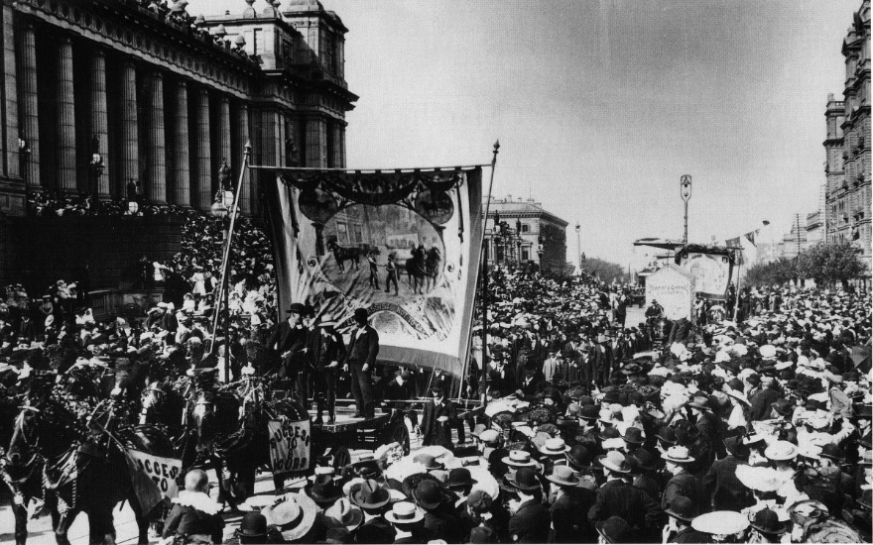

- The Eight-Hour Day banner is carried at a protest march.
In pairs, research into the 8-hour day. Complete these activities.
- Answer these questions:
- What was the aim of the Eight-Hour Day protest marches?
- What do you think was the impact of the introduction of the eight-hour day?
Show this in the bars below:
8hours | 8hours | 8hours

- Imagine you and your partner were living in the 1850s. Brainstorm the arguments you would present to:

Support the Eight-hour Day campaign  | Oppose the Eight-Hour Day campaign  

Strikes!

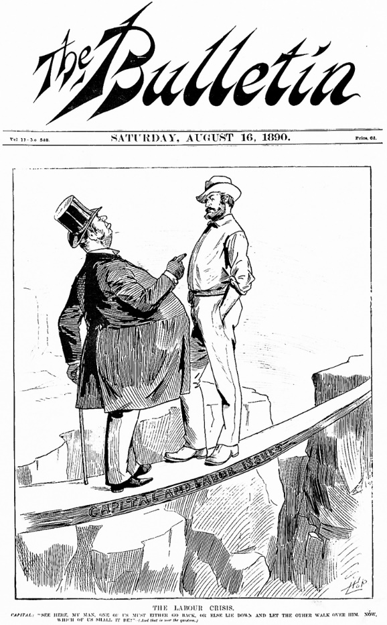
- Class discussion after viewing the cartoon.

- What power imbalances may exist between bosses and workers?
______________________________________________
______________________________________________
______________________________________________
______________________________________________
______________________________________________
______________________________________________
______________________________________________
______________________________________________

- This cartoon was published during the ‘Great Strikes’, especially the Maritime Strike of 1890 and the Shearer’s Strike of 1891. Complete the cloze passage.
CAUSE: Marine Officers’ affiliation with the Melbourne Trades Hall Council – they wanted to keep ___________________ apart. OUTCOME: The Maritime Strike was a defeat for the trade unions – but hope endured. As a result of the ___________________ the movement was united, and membership ___________________ dramatically in response to the struggle
CAUSE: The 1891 shearers' strike, between unionised and non-unionised ___________________ workers, is one of Australia's most important industrial disputes. OUTCOME: The strike was poorly timed, and when the union workers ran out of ___________________, they were forced to come to terms. The outcome is credited as being one of the factors for the formation of the Australian ___________________ Party.
TERM BANK: Labor / strike / food / increased / wool / unions
- What do worker and their unions strike about in 2025?
_______________________________________________________________________________________________________________________________________________________________________________________________________________________________________________________________________________________________________________________________________________
From the syllabus: Employment & Work Futures
The workplace
Students:
Compare the types of work and work arrangements, including full-time, part-time, casual, at home, paid, unpaid, voluntary, apprenticeships, traineeships
Examine various sources of income, including wages and salaries, commissions, profits and dividends investigate how the nature of work has changed and how it is likely to change in the future, including:
– the use of statistical data to examine patterns of employment
– the emergence of the sharing economy
– changes in the nature of work and workplace arrangements due to the impact of technology and globalisation
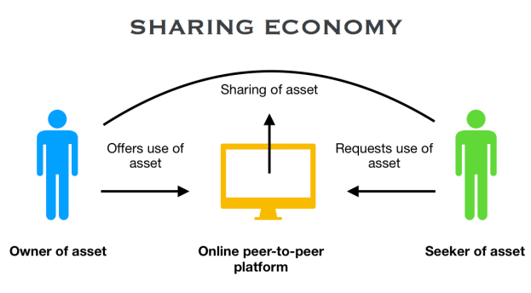

The Sharing Economy and How it Is Changing Industries
By Derek Miller Updated June 25, 2019
The sharing economy is one of the fastest growing business trends in history, with investors dumping more than $23 billion in venture capital funding since 2010 into startups operating with a share-based model. Because many of these businesses are private, it’s impossible to know the actual size of the sharing economy.
However, there are several clues to indicate its massive impact on our society.
- Airbnb ($31 million) and Uber ($72 billion) have a combined $103 billion market cap which would rank them as the 38th wealthiest country in the world.
- In 2016, 44.8 million U.S. adults used the sharing economy, and it’s expected to grow to 86.5 million U.S. users by 2021.
- McKinsey estimates that in the U.S. and Europe alone, 162 million people or 20-30 percent of the workforce are providers on sharing platforms.

What Is the Sharing Economy?
Trying to define exactly what the sharing economy is would not do the term justice. The sharing economy is an economic principle that is constantly evolving. In the very simplest terms, it’s the use of technology to facilitate the exchanged access of goods or services between two or more parties.
It’s derived from the notion that mutual parties can share value from an under-utilized skill or asset. This value exchange occurs through a shared marketplace, collaborative platform, or peer-to-peer application.
The sharing model isn’t a new concept—as many rural communities thrived off the same idea via bartering. However, thanks to the accessibility of the internet and mobile technology, managing share-based transactions has never been easier.
While most commonly referred to as the sharing economy, this term is an umbrella that encompasses other economic systems such as:
- Collaborative Economy/Collaborative Consumption
- Peer-to-Peer Economy
- Freelancing/Gig Economy
- Crowdfunding/Crowdsourcing
- Coworking/Cobranding

What Is the Impact of the Sharing Economy?
The sharing economy has a history of disrupting traditional business sectors. The lack of overhead and inventory help share-based businesses run lean. The increased efficiencies allow these brands to pass-through value to their customers and supply chain partners.
Traditional industries are being affected by the sharing economy—and many traditional brands will struggle if they do not adapt to the changing landscape.

Transportation
Uber’s ascension in the transportation industry is one of the best examples to illustrate the effect of the sharing economy in a traditional sector. Uber and other ride-sharing services offer an affordable, safe, and convenient alternative to traditional transportation options such as public transit or taxi cabs.
By utilising an efficient mobile application and network of vetted drivers, Uber satisfies consumers’ transportation demands while providing an arguably better user experience than traditional means.
In just New York City alone, there are roughly 4.5 times more Uber drivers than yellow cabs. This has caused the price of owning a taxi cab in New York City to drop from $1 million in 2015 to less than $200,000 today.
Top Sharing Economy Brands in the Transportation Space:
- Uber: $72 Billion
- Didi: $50 Billion
- Lyft: $11 Billion

Consumer Goods
PWC research suggests that 86 percent of U.S. adults familiar with the sharing economy say that it makes life more affordable and 83 percent also agree that the sharing economy is more convenient and efficient than traditional methods.
Affordability, convenience, and efficiency are also three of the most influential factors in a consumer goods purchasing decision. Therefore, it’s no surprise that share-based brands are also dominating the consumer goods industry.
eBay is one of the pioneers of the peer-to-peer marketplace. Their innovative platform allows users to buy and sell used or new items through their interface, and have the goods shipped directly to their home. Consumers can browse a variety of products at custom price points, in various conditions, and with different guarantees. This empowers the consumers and provides them with a more affordable, convenient, and efficient way to purchase goods.
Top Sharing Economy Brands in the Consumer Goods Space:
- eBay: $36.8 Billion
- Etsy: $5.2 Billion
- Rent the Runway: $800 Million

Professional and Personal Services
The benefits of the sharing economy are best illustrated in the professional and personal services space. Professional and personal services are defined by work that requires special knowledge, skills, experience, certifications, or training like copywriters, accountants, or plumbers. In relation to the sharing economy, this is also referred to as freelancing, gigs, and other trendy terms equating to short-term labor.
Powerhouses like Fiverr, Upwork, and TaskRabbit create value by providing a fast, friendly, and secure platform on which people or businesses can find contractors for hire. Freelancers can earn extra money sharing their trade skills and expertise—not unlike owners renting access to their home or car owners sharing rides.
Top Sharing Economy Brands in the Professional and Personal Services Space:
- Fiverr: $351 Million
- Upwork: $168.8 Million +
- TaskRabbit: $50 Million +

Healthcare
The healthcare industry is expected to generate annual revenues of $8.7 trillion by 2020. That likely explains why venture funding for digital health startups increased by 10.2 percent in Q1 of 2018 compared to Q1 of 2017. Although the sharing economy has yet to really take hold in the healthcare industry, many experts suspect it to be the next frontier for collaborative consumption.
The limitations of traditional healthcare systems, expenses and resources, are factors that we’ve seen mitigated in other industries through share-based methods. From telemedicine to group-consultations, the sharing economy is destined to change the healthcare industry.
For instance, it’s estimated that 58 percent of the time, medical equipment sits unused—creating storage and maintenance expenses. Therefore, share-based startups like Cohealo are helping hospitals save money and increase equipment value by developing technology that enables hospitals to share medical equipment with other healthcare facilities.
Top Sharing Economy Brands in the Healthcare Space:
- American Well: $441.5 Million
- Doctor On Demand: $160 Million
- Cohealo: $9 Million +

What Is Next for the Sharing Economy?
Technology has helped the sharing economy advance to where it is today—and, the trend should only continue as we become more connected digitally. While we’ve seen how dominant collaborative consumption can be in industries like transportation, consumer goods, and services, many other traditional sectors will soon experience changes because of the sharing economy.
SOURCE: https://www.thebalancesmb.com/the-sharing-economy-and-how-it-changes-industries-4172234

ACTIVITIES
- Define the sharing economy in your own words.
______________________________________________________________________________________________________________________________________________________
- Highlight the companies that you have heard of before.

- Research ONE company that you have not heard of before and provide a summary of its operations.
____________________________________________________________________________________________________________________________________________________________________________________________________________________________________________________________________________________________________________
- State the three most influential factors in consumer goods’ purchasing decisions.
_________________________________________________________________________________________________________________________________________________________________________________________________________________________________
- How has technology contributed to the sharing economy?
____________________________________________________________________________________________________________________________________________________________________________________________________________________________________________________________________________________________________________

From the syllabus: Employment & Work Futures
Rights and responsibilities in the workplace
Students:
investigate the roles of various participants in the workplace, including employers, employees, contractors, industrial organisations/unions, state/territory and Commonwealth governments
explain changes to the roles of employees in the workplace, for example the increasing encouragement for workers to show initiative
discuss employer responsibilities to workers and the government, for example superannuation, paid parental leave, pay as you go (PAYG) withholding, income tax, company tax or the Goods and Services Tax (GST)
examine laws related to the workplace, including:
– Work Health and Safety (WHS) legislation
– Equal Employment Opportunity and anti-discrimination laws
– penalty rates and the role of the Fair Work Commission
identify methods of resolving disputes, including grievance procedures, negotiation, mediation, arbitration
What do these terms mean?
contractor? _______________________________________________________________
_________________________________________________________________________

union? ___________________________________________________________________
_________________________________________________________________________

Fair Work Commission? ____________________________________________________
_________________________________________________________________________

penalty rates?_____________________________________________________________
_________________________________________________________________________

grievance procedures? _____________________________________________________
_________________________________________________________________________

mediation? _______________________________________________________________
Rights and responsibilities in the workplace

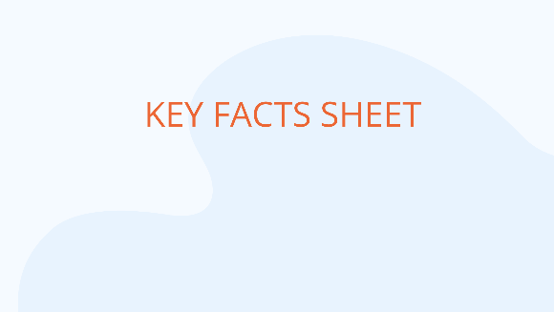
Produce a FACT SHEET young people who are about to start their first job providing information about their rights and their responsibilities to their employer in the workplace.
To create your guide, you will need to
- decide on what kind of workplace this guide relates to
- determine what kinds of jobs young people might have as their first job
- consider which rights and responsibilities will be the most important for them to know about in detail, and which you can include less detail about
- consider whether you might include links to websites for more information, or organisations that can offer help or advice in your local area
- write down the main and subheadings you will use so that you have a clear structure in mind before you start writing.

Remember this is their first job, so you will need to consider the kind of information that is important, and the level of detail required.
Some (but perhaps not all) of the things you might cover are listed below:
- income rates, tax and superannuation
- understanding important documents (contracts, payslips)
- workplace safety
- discrimination
- daily expectations (dress, punctuality, hours etc.)
- leave entitlements

TEXT BOOK WORK!!
An unhealthy working environment
Read through subtopics 3.10 and 3.11, which contain information about a variety of legal issues that relate to the workplace. While you may be familiar with some of the content, it may benefit you to consider how these problems can affect you in the workplace.
Imagine that you are working in a place that has no proper workplace health and safety procedures in place and workplace bullying and discrimination is the norm rather than the exception. Answer the questions below using as much description as you can.

- What might the workplace look like?
________________________________________________________________________________
________________________________________________________________________________
________________________________________________________________________________
________________________________________________________________________________

- What might the workplace sound like?
________________________________________________________________________________
________________________________________________________________________________
________________________________________________________________________________
________________________________________________________________________________

- What might the workplace ‘feel’ like?
________________________________________________________________________________
________________________________________________________________________________
________________________________________________________________________________
________________________________________________________________________________

Needless to say, this workplace is dangerous to both your physical and psychological wellbeing. However, not only is the work environment risky for the workers, but it can also lead to a decrease in the company’s profit.

- Suggest three reasons these conditions would cause the company’s profit to decline over time.
________________________________________________________________________________
________________________________________________________________________________
________________________________________________________________________________
________________________________________________________________________________
It is easy to see that the employee and employer would benefit from an improvement in the conditions of this workplace. However, in order to facilitate change, you need to have a plan and a strategy.

- Come up with five ideas that would improve the working conditions and benefit the company if implemented.
Problem | Strategy | Time frame | Desired outcome
Share your ideas with the rest of the class and be prepared to justify your strategies.
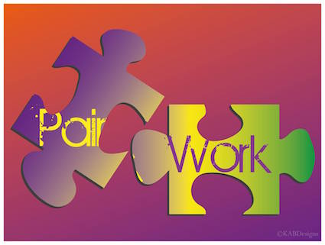
PAIR WORK!!
Prepare brief word-processed summaries, in pairs, for the class on:

TOPIC | TEXTBOOK PAGES | PAIR
History of trade unions | 120-121
Role of trade unions | 122-123
Employer associations | 123-124
Forms of income | 129-130
Labour force participation | 134-136
Employment contract | 145
Modern awards | 146
Enterprise agreements | 147
Common law contracts | 148
National Employment Standards (NES) | 149
Paid Parental Leave | 154
Superannuation | 155
WHS | 158
Bullying in the workplace | 159
Anti discrimination | 161-162
Unfair dismissal | 162-163
Social & Personal costs of unemployment | 168

RESOLVING DISPUTES

Instructions:
Design a cartoon strip to show how a workplace grievance is resolved in the workplace.

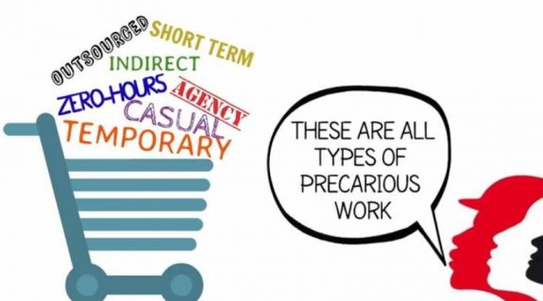
INSECURE WORK

Introduction

We’re going to introduce the term, ‘insecure work’. This is a term which encompasses a number of types of work where people do not have many of the rights of those who work full-time and part-time.
Many of the issues around insecure work have been made more prominent by the COVID-19 pandemic.
Last week we said that employment is generally full-time, part-time or casual. But in 2020, the types of employment have evolved considerably from these broad categories. This paragraph from an article in The Conversation sums it up well:

“The bog-standard job of the 20th century was formal, full-time and permanent. Recently the lexicon for other kinds of jobs has expanded. Work can be temporary, fixed-term, seasonal, project-based, part-time, on a zero-hours contract, casual, agency, freelance, peripheral, contingent, external, non-standard, atypical, platform-based, outsourced, ‘gig’, sub-contracted, informal, undeclared, insecure, marginal or precarious.”
Word Check

‘Bog-standard’: basic or standard

‘Lexicon’: the vocabulary of a person

What do we mean by ‘insecure work’?

Uncertainty over the length of the job
Some workers may not know how long their work is going to last

Irregular and unpredictable work hours
Workers don’t know when they will be offered their next shift

Inferior Entitlements
People in insecure work usually don’t have access to sick leave or other types of leave. If they are sick, they don’t get paid

Unpredictable pay
People in insecure work can never be sure what they will earn from one week to the next

Underemployment
Many workers in insecure work want to be working more hours than they do
Examples might include:
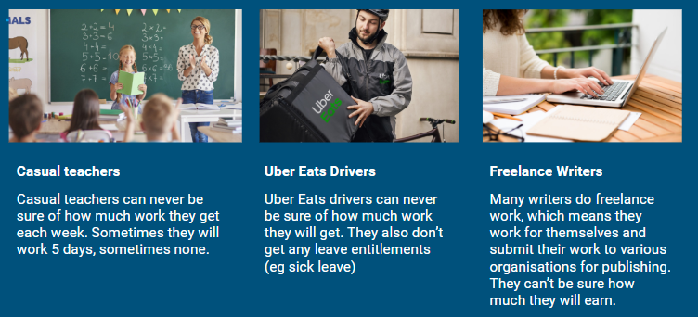
Well, so what?
Why does this matter?
Insecure work does exactly what its name suggests, it makes life very insecure for people. If people don’t know for certain when their next pay is coming, it makes it very difficult to make day-to-day decisions and leads to significant uncertainty in their lives. This can have significant effects on mental wellbeing, especially if they are supporting a family. Insecure workers also miss out on many of the work entitlements of permanent employees, like sick pay. This means if they are unable to work on a day owing to ill health, they will not get paid that day. These are just some of the multitude of issues with the rise in insecure work.
Complete table of advantages and disadvantages of insecure work

Advantages of insecure work | Disadvantages of insecure work


Now what you think about insecure work?

Task 2: Writing Task

Discuss the consequences of the rise insecure work (use points from the table above). Write a PEEL paragraph.

________________________________________________________________________________________________________________________________________________________________________________________________________________________________________________________________________________________________________________________________________________________________________________________________________________________________________________________________________________________________________________________________________________________________________________________________________________________
_____________________________________________________________________________________________________________________________________________________________________________________________________________________________________________________________________________________________________________________________________________________________________________________________________________________________________________________________________________________________________________________________________________

